In chrome browser with the help of blazer meter script is recorded

First go to login page, enter username and password

https://the-internet.herokuapp.com/login

Go to below link,

https://the-internet.herokuapp.com/

Click on first link

Go to below link,

https://the-internet.herokuapp.com/

Click on second link

Go to below link,

https://the-internet.herokuapp.com/

Click on third link

Go to this page and click on logout button

<https://the-internet.herokuapp.com/login>

and the recorded script is saved in download folder

Then click on folder In jmeter then select the downloaded folded which is scripted 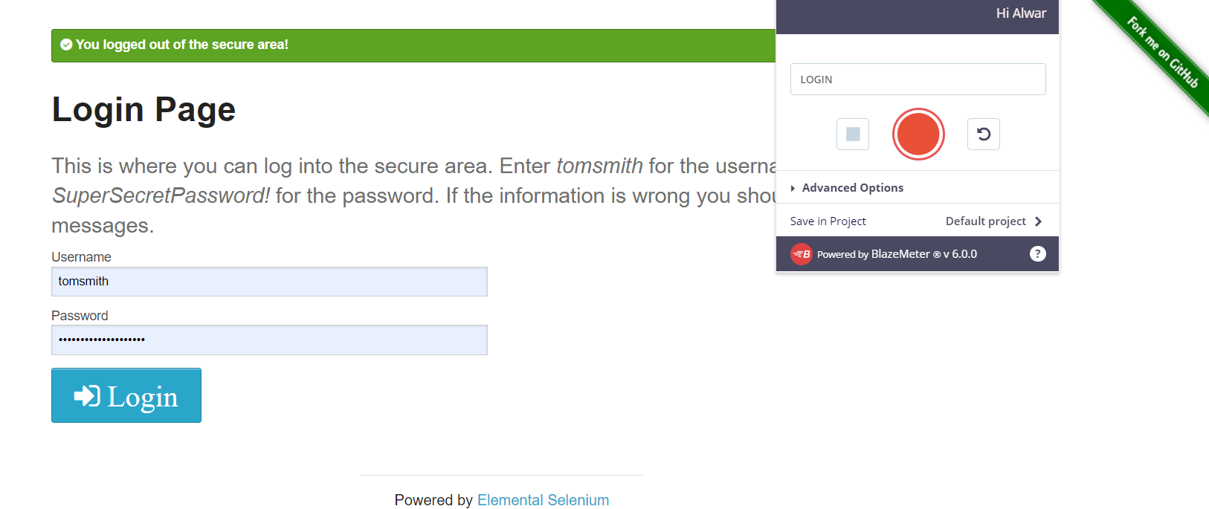Naming Test plan as switch controller 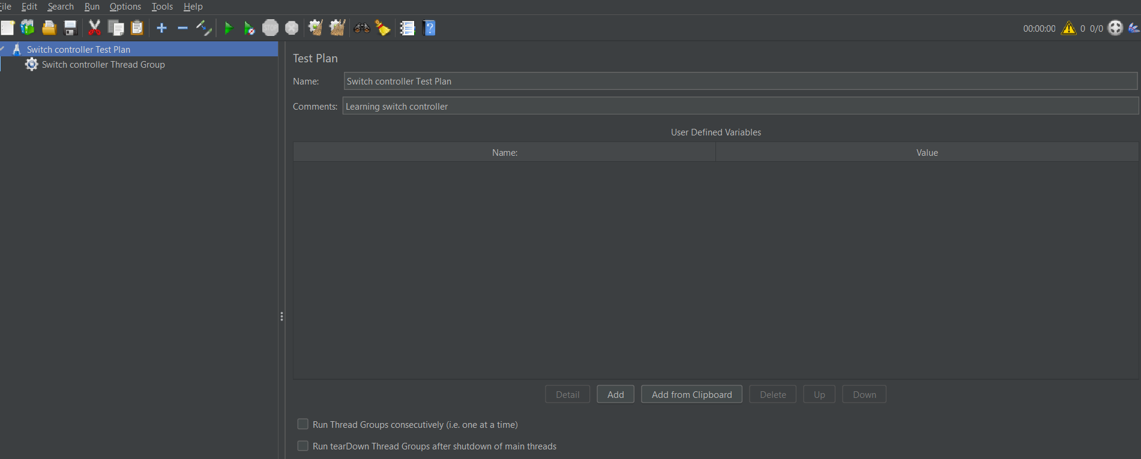

Then name thread group as switch controller thread group.

Adding switch controller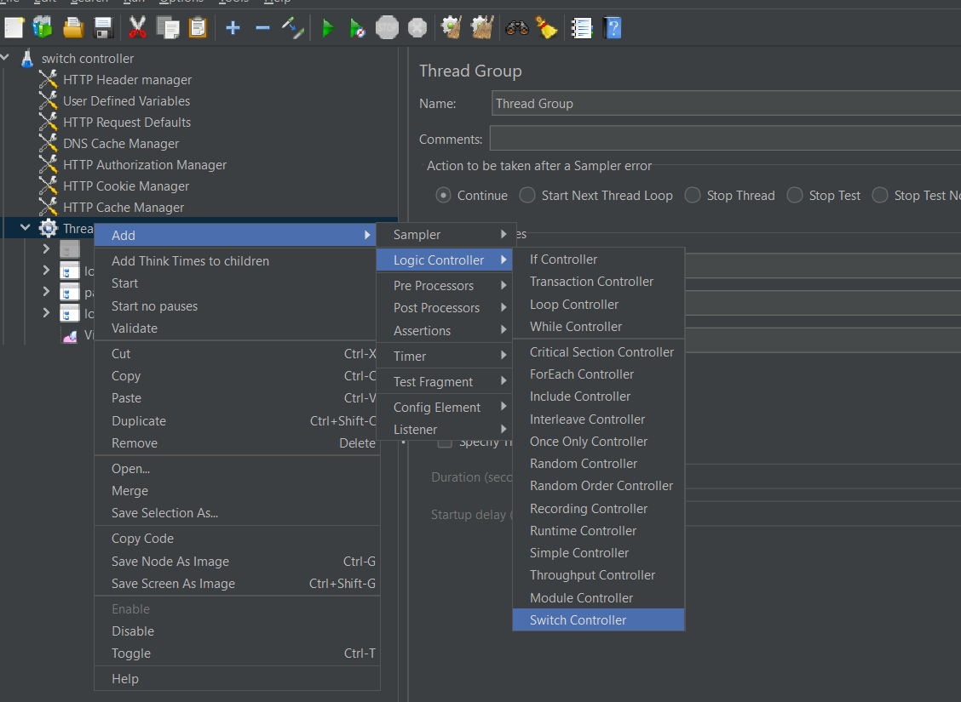

In switch controller we are adding simple controller to execute

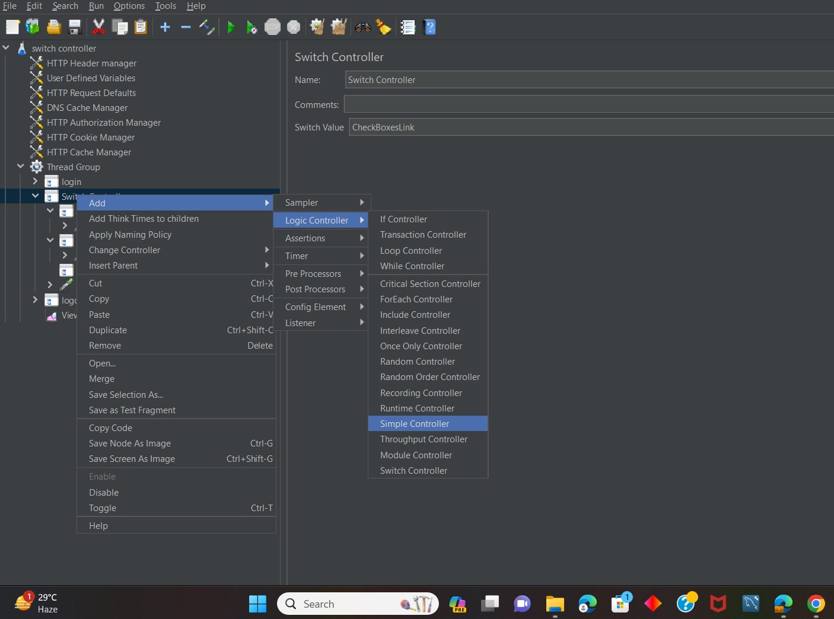

Giving simple control name as abtestlink,and placing the script in it

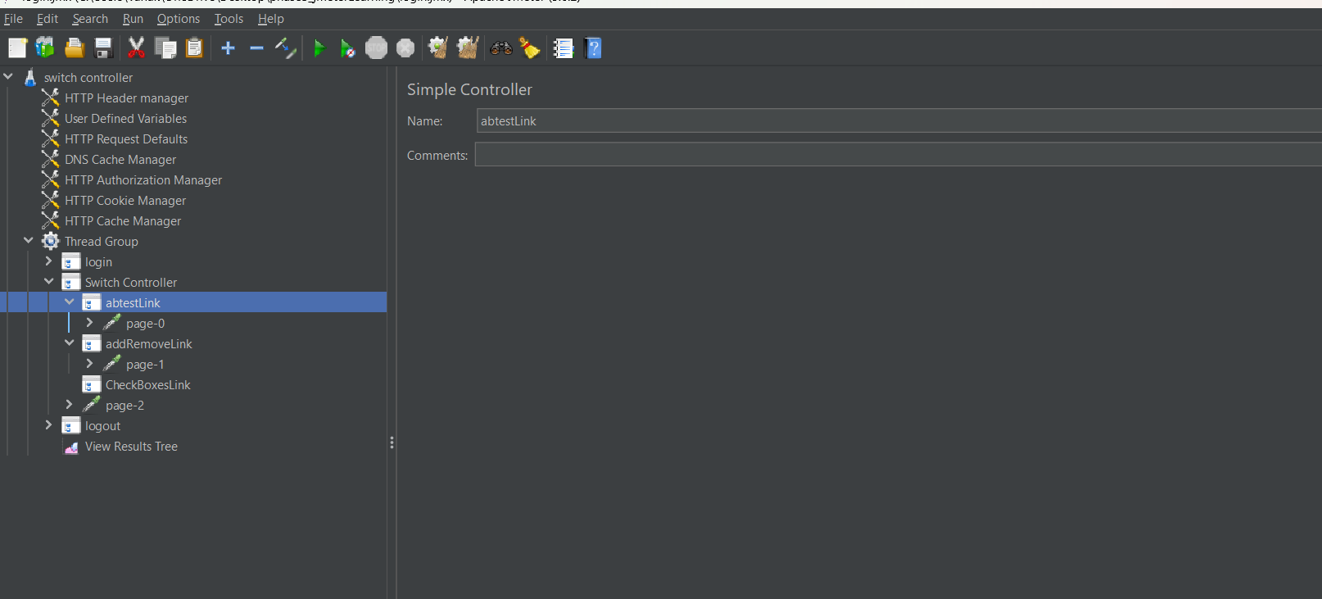

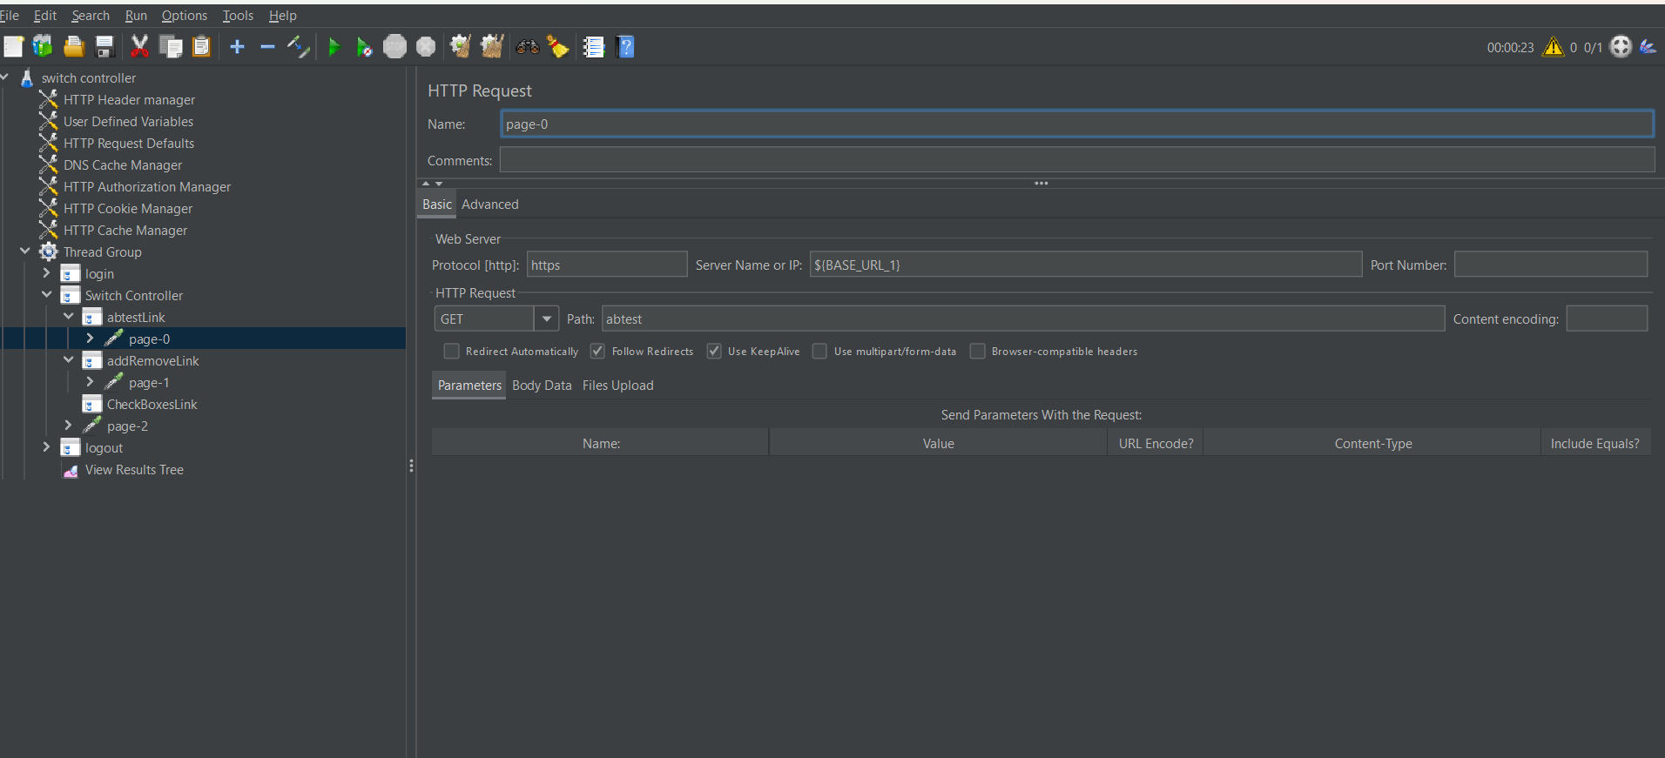

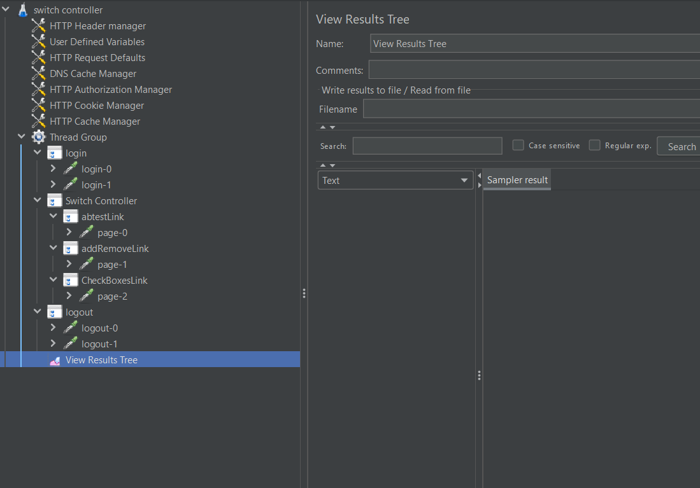

Giving switch value as CheckBoxesLink

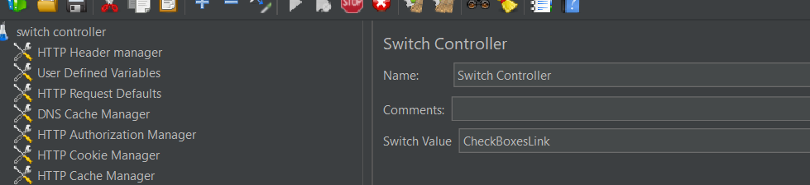

Result as shown below

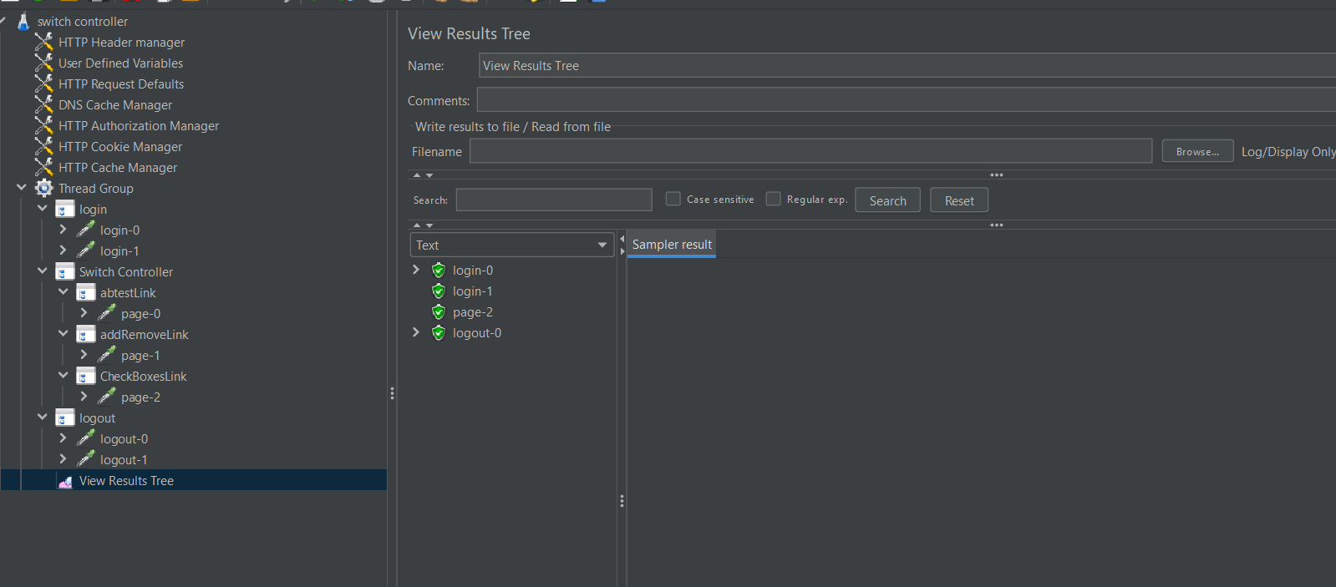

Extra:-If we add loop count-03

Then the output for that scenario :-

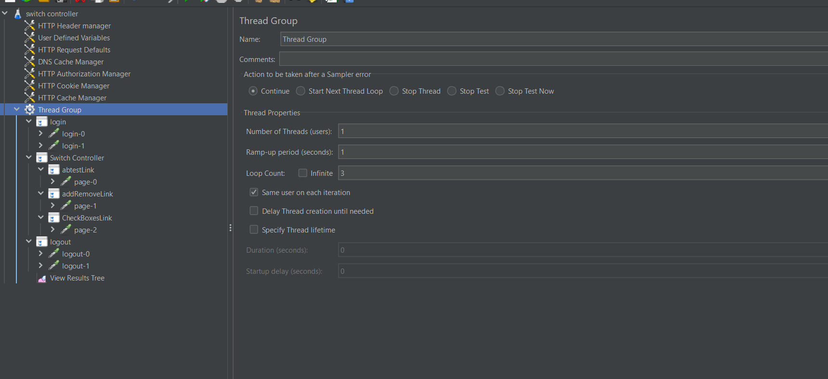

Execute the thread group by clcik on the run button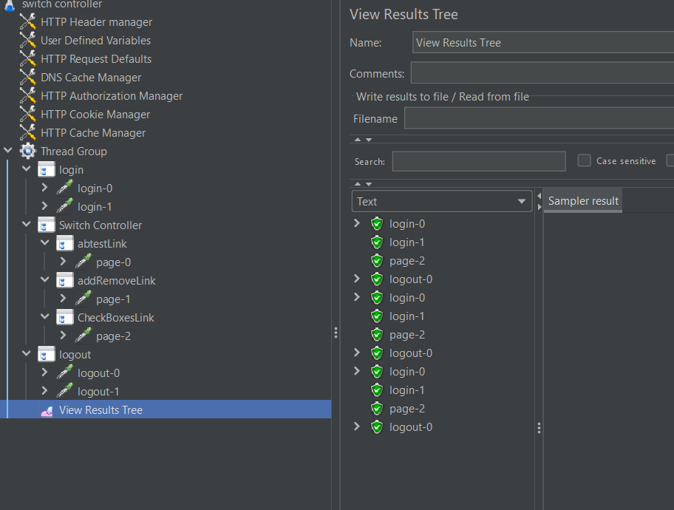

Include Controller

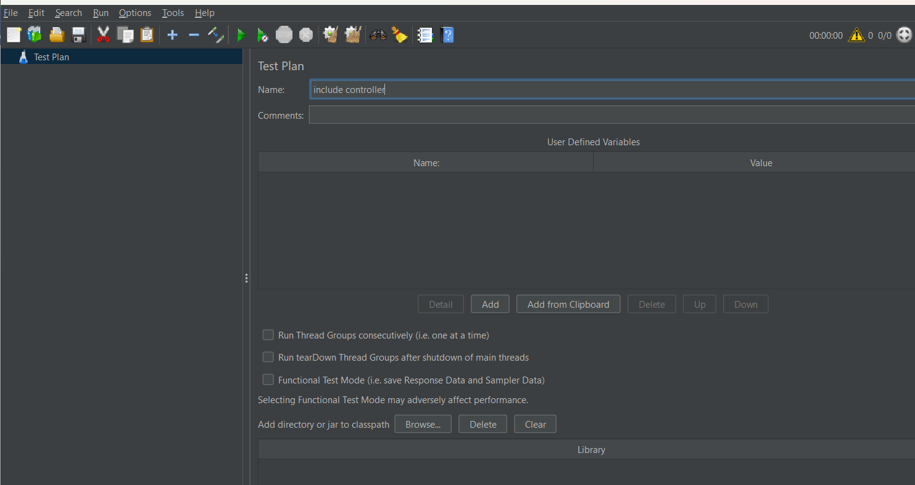

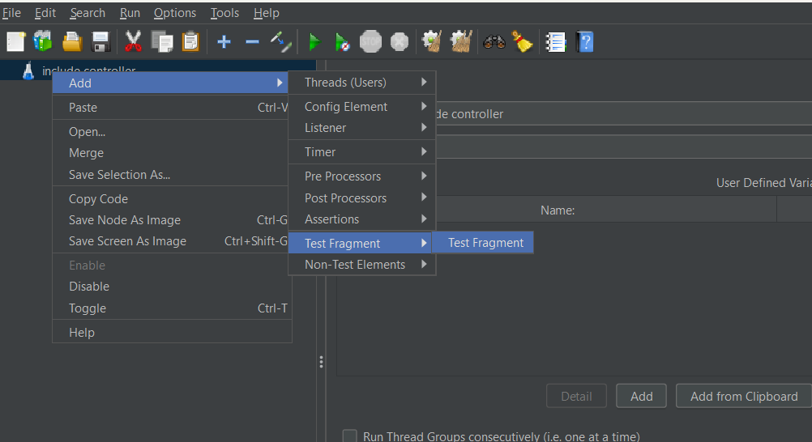

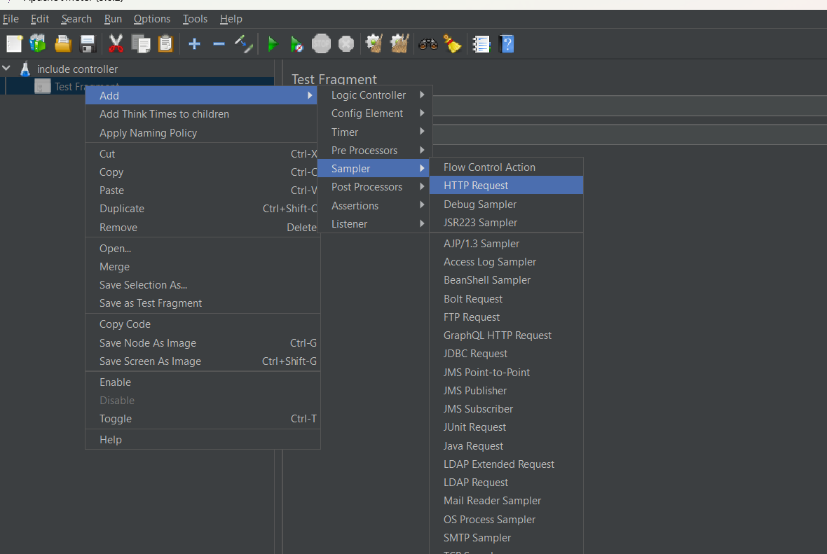

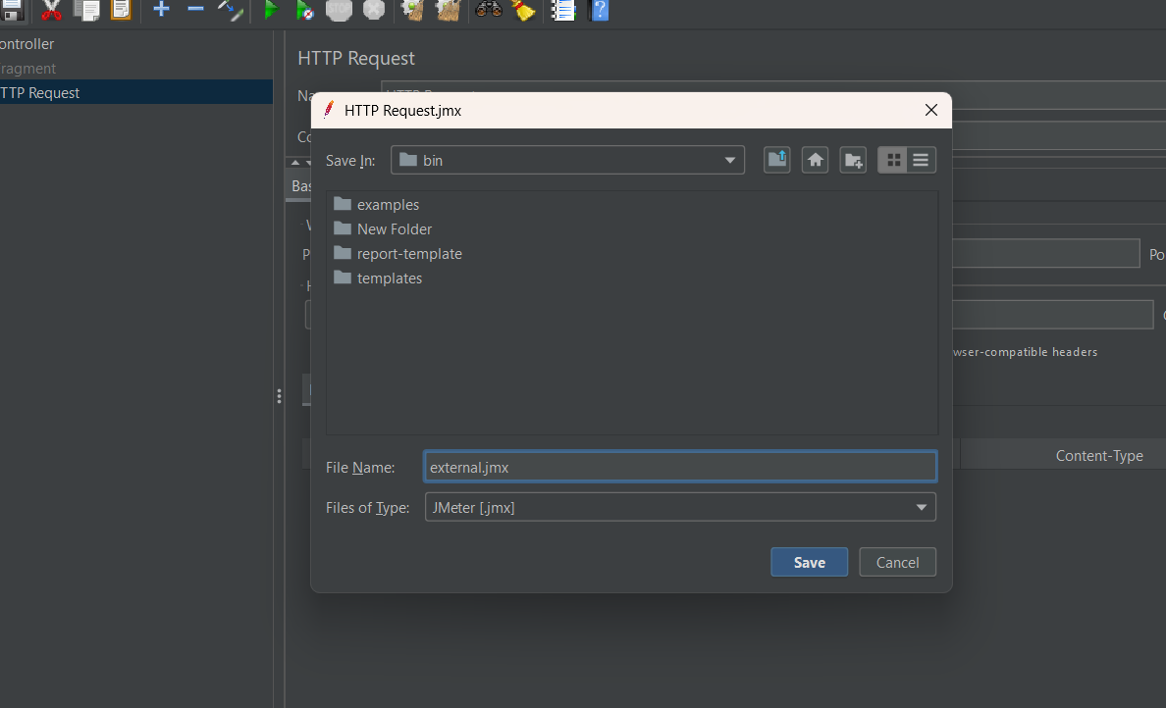

Already existing file ,add threadgroup

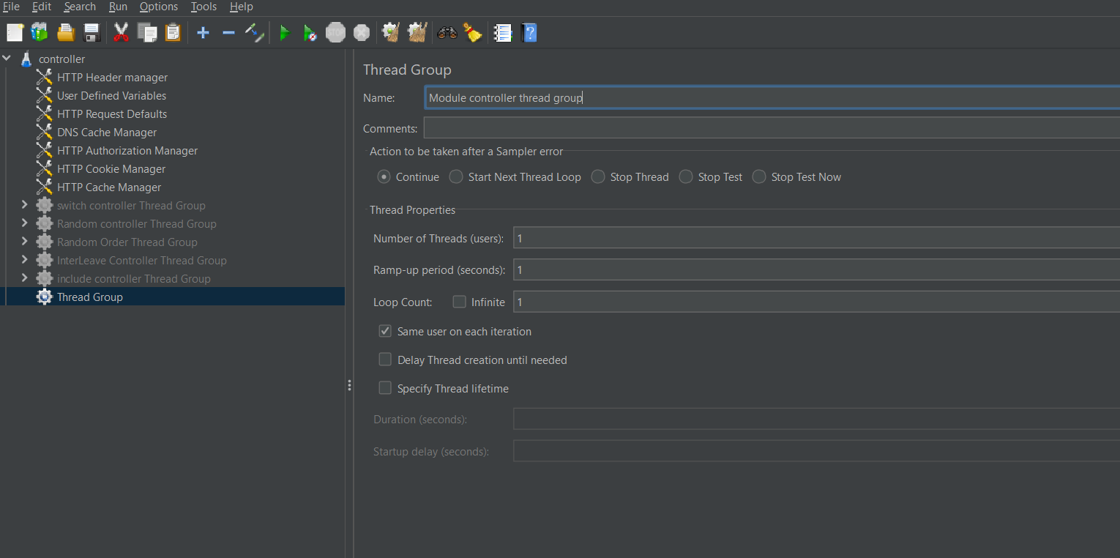

Adding logic controller-module controller to thread group.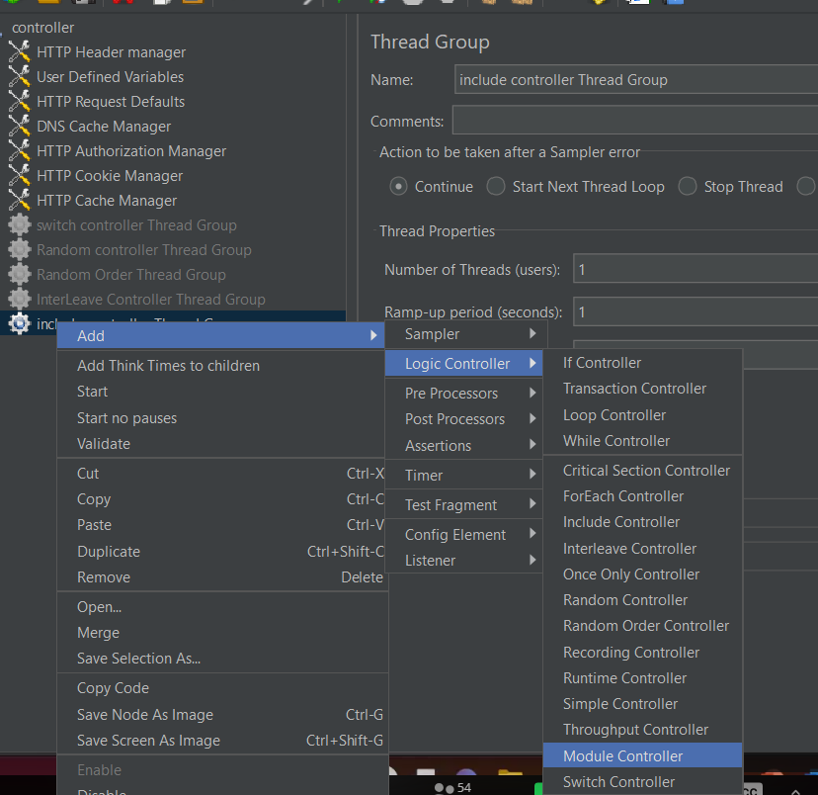

Select the test sample which we want execute.

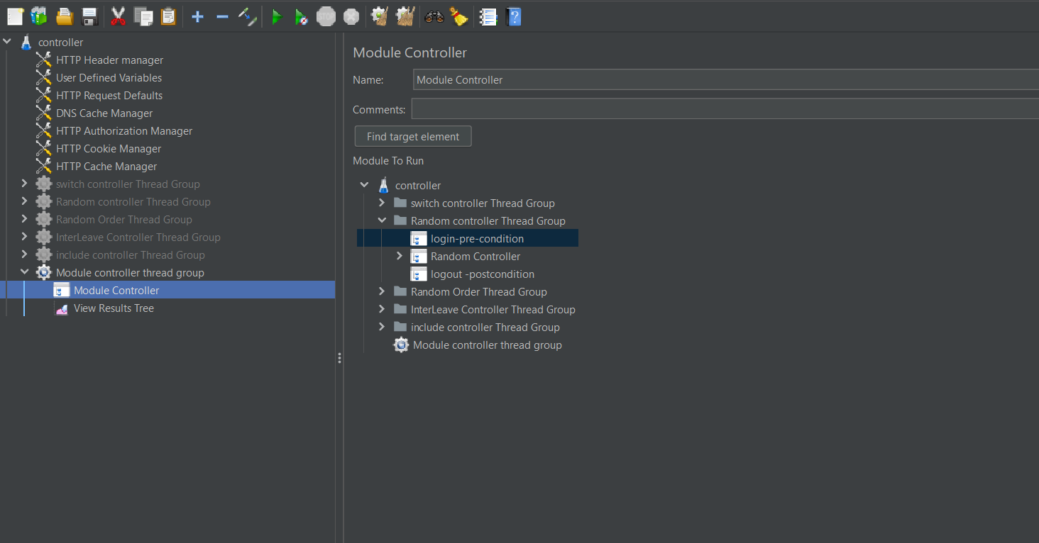

Click on run button to execute the module controller Thread Group.